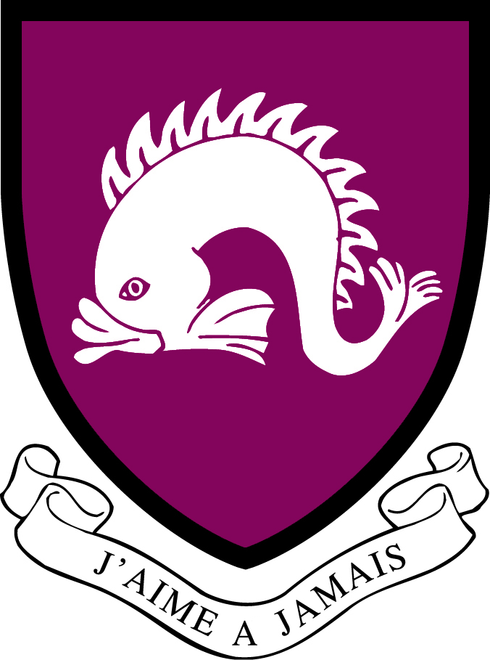
Northbourne Park School
Job Description

Job Title: Early Years and Nursery Practitioner
Department: Pre-Prep (EYFS)
Reporting to: Nursery Room Leader/ Class Teacher and Head of Pre-Prep

Overall Purpose of the Job:
- To work as part of the EYFS team, supporting the Nursery Room Leader by contributing to learning and care of children in the setting.

Principal Responsibilities:

- To be responsible for safeguarding and promoting the welfare of children.
- To assist the Nursery Room Leader and Head of Pre-Prep to deliver the Early Years Foundation Stage curriculum.
- Provide support for learning activities by making a contribution in the planning and evaluation of learning activities and supporting the delivery of learning activities
- To work with groups on planned focussed activities in both the indoor and outdoor learning environments.
- To support individual pupils with specific learning difficulties.
- To carry out daily planning and assessment as requested by the Nursery Room Leader and Head of Pre-Prep
- To attend parents’ evenings as appropriate.
- To write progress reviews and reports as required.
- To observe, record and update children’s individual assessment and data as appropriate.
- To supervise children in the dining room and during playtime as requested.
- To set up the teaching areas and prepare activities.
- To create displays and organise a lively learning environment.
- To assist with practical activities and specialist lessons.
- To assist the Head of Pre-Prep in the planning and production of performances to parents.
- To assist in the planning of educational visits.
- To undertake Professional Development in line with the School Improvement Plan.
- To follow all school policies.
- To attend weekly planning meetings, staff briefings, all staff meetings, training days, development days, and any other committees as required.
- To carry out any reasonable tasks as directed by the Head.

Personal Specification (Knowledge, Skills & Attributes)
Essential requirements for the role:
- Full and relevant Early Years qualification at Level 2 or 3 (e.g. QTS, CACHE diploma, Level 3 Childcare & Education or Early Years equivalent qualification.)
- Ability to work as a resourceful member of a team.
- Flexible and proactive attitude to work.
- Honest, reliable and trustworthy.
- Experience supporting young children

Desirable requirements:
- GCSE Grade C in English and Maths.
- Knowledge of the EYFS Statutory Framework.
- First Aid and Food Hygiene qualificiations.

Safeguarding
Northbourne Park School is committed to safeguarding and promoting the welfare of children. Candidates will be required to complete an application form and produce original documentation of certificates and degree qualifications. An enhanced DBS clearance check will be undertaken for the successful candidate. All staff members are expected to fulfil their obligations and responsibilities in safeguarding and promoting the welfare of children.

Updated September 2025. This job description is subject to review and change as necessary.

